Set in python

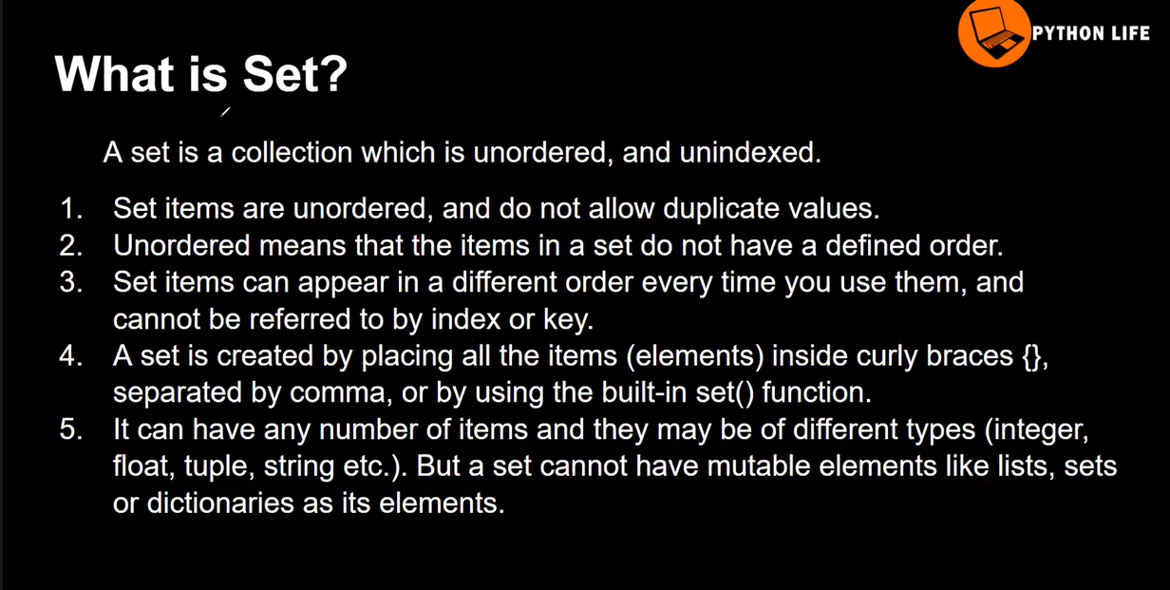
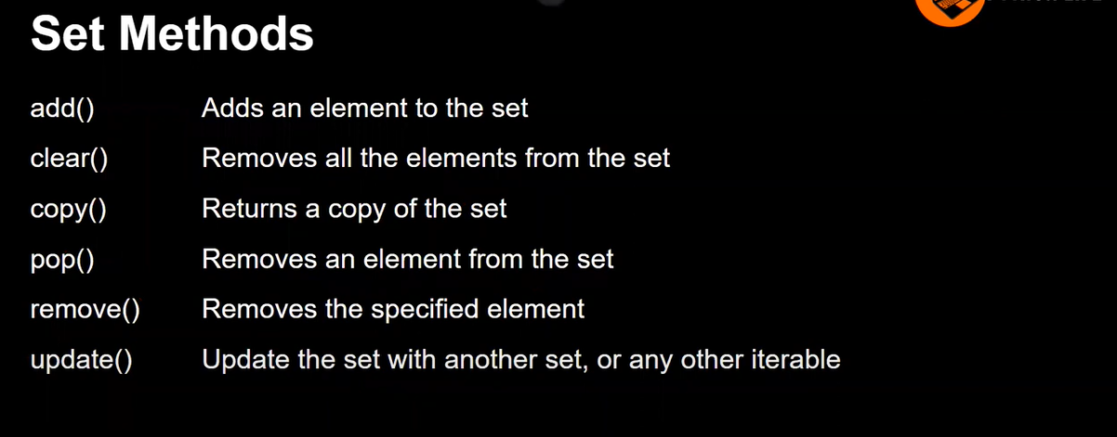
Default it taken has dictionary

Unorderd and un indexed
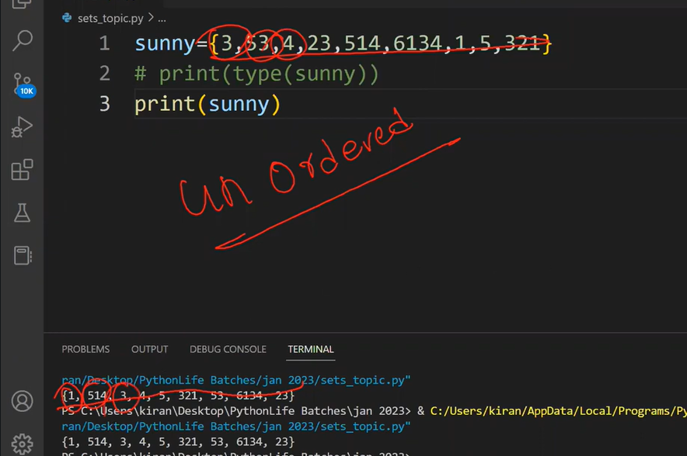
It won’t allow the duplicate
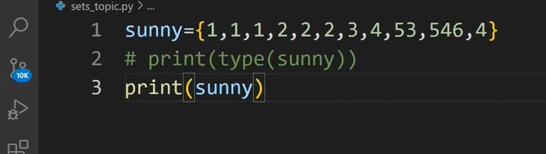
data using Update() method
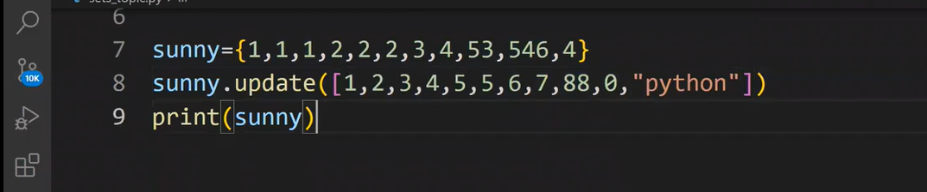
Remove() method which is used to remove the element
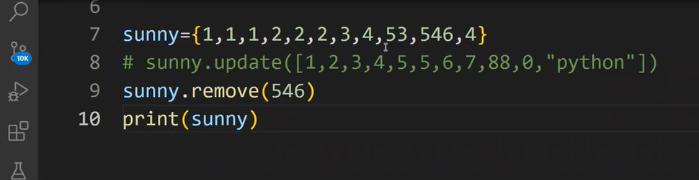
Pop() method which is used to remove the element randomly (or) smallest element
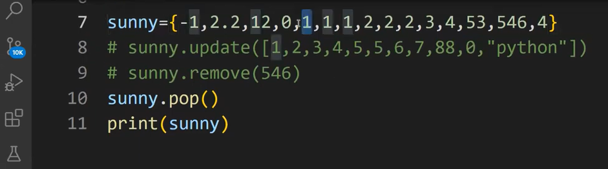
All method in set
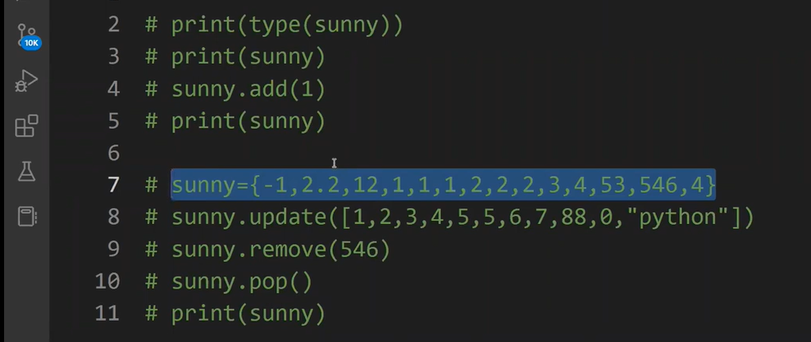
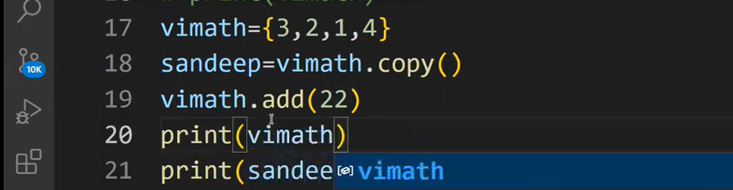

Set operation
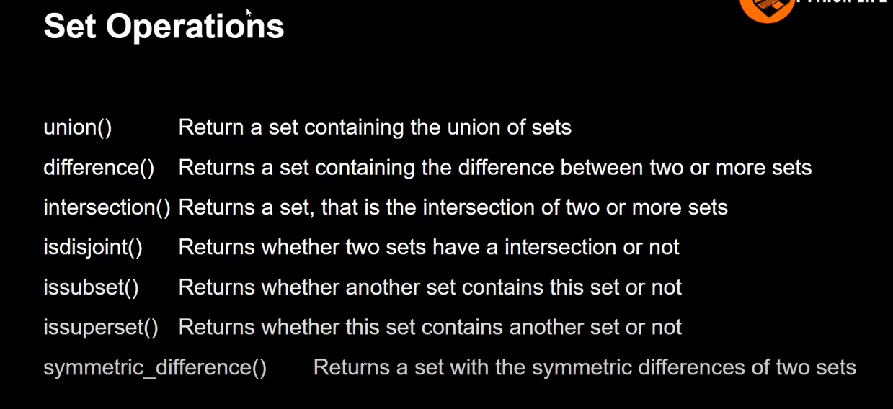
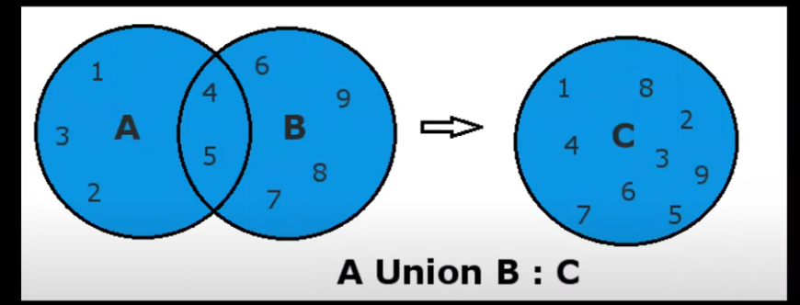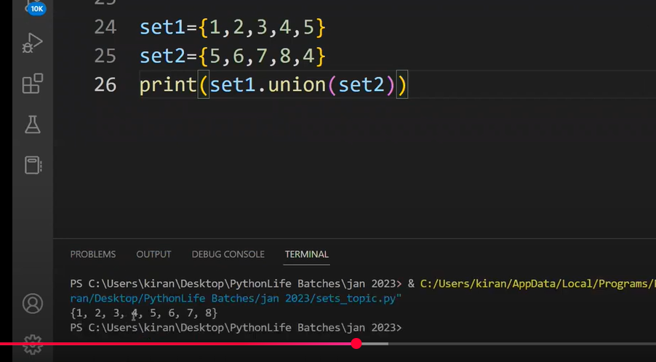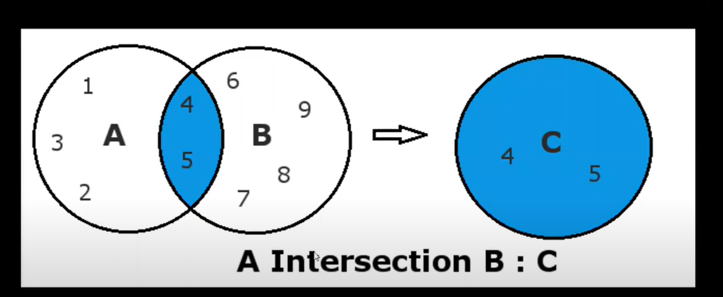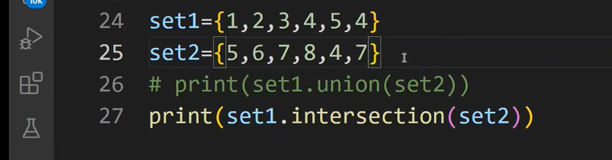

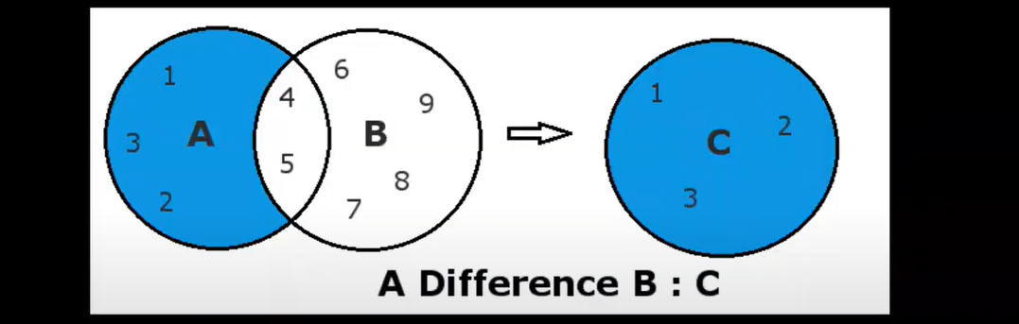
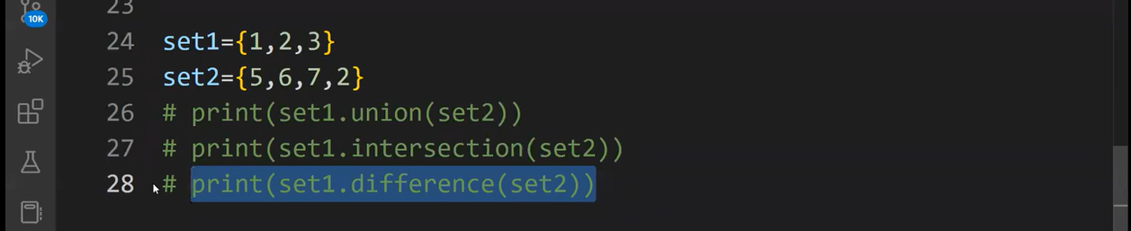
Semantic difference 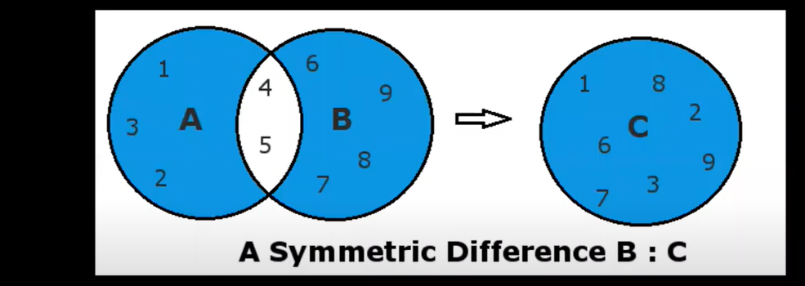
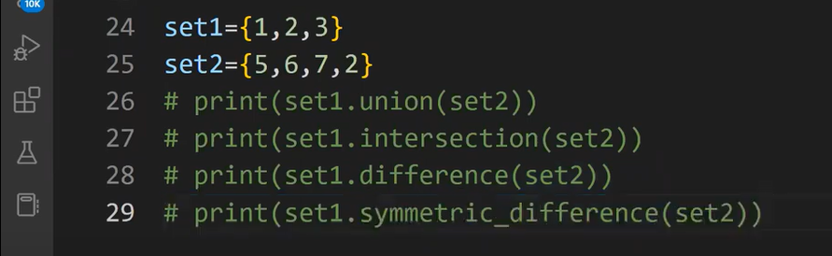
Isdisjoint() it will shown as true of false comparison 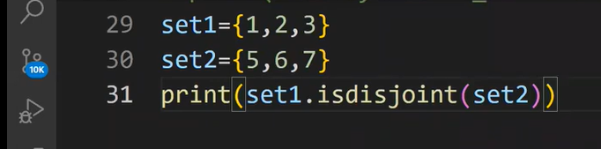
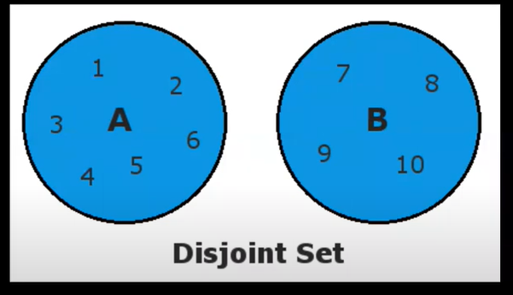
Subset which also show an true or false cases

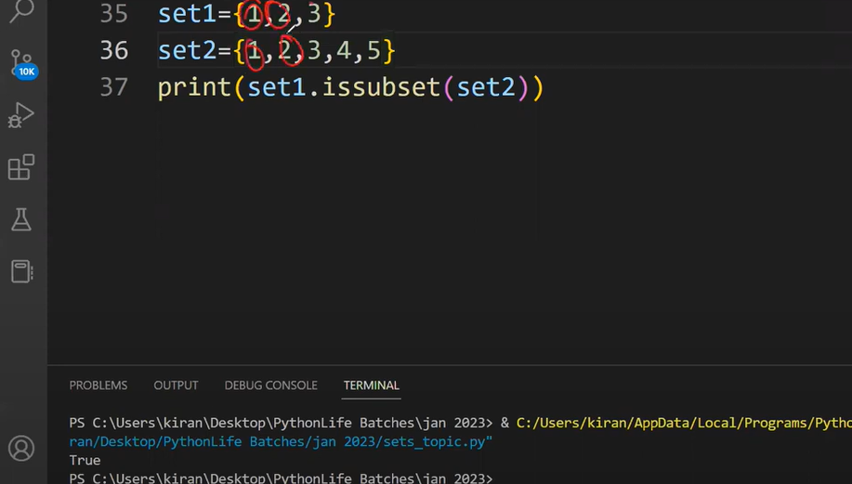
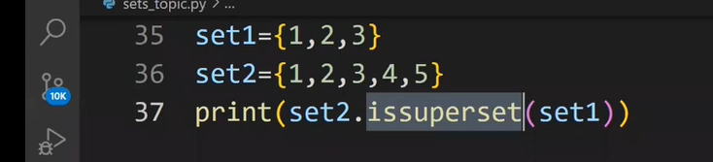
frozen set
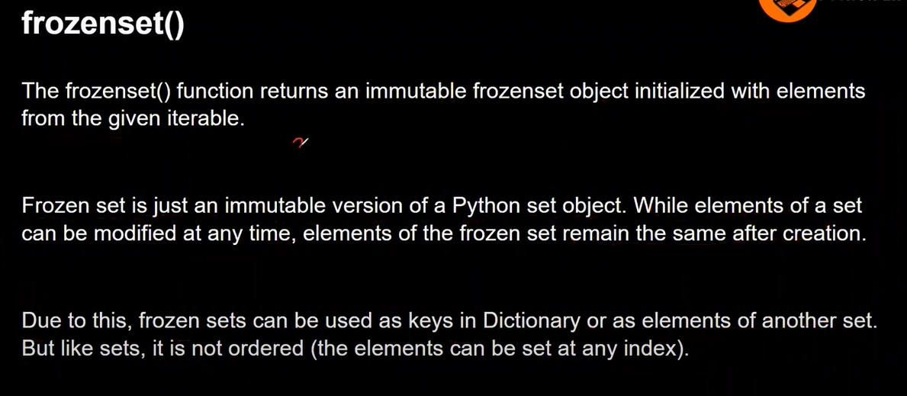

Mini project
# super market Bill geneation

from datetime import datetime

name = input("eneter you name :")

lists = '''

"Rice" ₹300 / 5 kg
"Wheat Flour (Atta)" ₹250 / 5 kg
"Toor Dal": ₹280 / 2 kg
"Sugar": ₹90 / 2 kg
"Salt": ₹20 / 1 kg
"Cooking Oil" ₹150 / 1 L
"Milk": ₹120 / 2 L
"Tea Powder": ₹200 / 0.5 kg → ₹400/kg
"Turmeric Powder": ₹30 / 0.1 kg → ₹300/kg
"Red Chili Powder": ₹60 / 0.2 kg → ₹300/kg
"Onion": ₹50 / 2 kg
"Potato": ₹40 / 2 kg
"Tomato": ₹45 / 1.5 kg
"Green Chilies": ₹15 / 0.25 kg
"Soap (Bath)": ₹80 / 4 pcs
"Detergent Powder": ₹60 / 1 kg

'''

# declaration

grocery_Items = {
"Rice": 60, # ₹300 / 5 kg
"Wheat Flour (Atta)": 50, # ₹250 / 5 kg
"Toor Dal": 140, # ₹280 / 2 kg
"Sugar": 45, # ₹90 / 2 kg
"Salt": 20, # ₹20 / 1 kg
"Cooking Oil": 150, # ₹150 / 1 L
"Milk": 60, # ₹120 / 2 L
"Tea Powder": 400, # ₹200 / 0.5 kg → ₹400/kg
"Turmeric Powder": 300, # ₹30 / 0.1 kg → ₹300/kg
"Red Chili Powder": 300, # ₹60 / 0.2 kg → ₹300/kg
"Onion": 25, # ₹50 / 2 kg
"Potato": 20, # ₹40 / 2 kg
"Tomato": 30, # ₹45 / 1.5 kg
"Green Chilies": 60, # ₹15 / 0.25 kg
"Soap (Bath)": 20, # ₹80 / 4 pcs
"Detergent Powder": 60 # ₹60 / 1 kg
}

price=0
price_list=[]
Total_price =0
final_price=0
plist=[]
ilist=[]
qlist=[]
option =int(input("Enter of items enter 1 "))
if option == 1:
print(lists)
for i in range(len(grocery_Items)):
inp1=int(input("If you wnat to buy press 1 or 2 for exit "))
if inp1==2:
break
elif inp1==1:
item=input("enetr your item in list: ")
quantity = int(input("enetr the Quantity "))
if item in grocery_Items.keys():
price=quantity*(grocery_Items[item])
price_list.append(item,quantity,price)
Total_price+=price
ilist.append(item)
qlist.append(quantity)
plist.append(price)
gst=(Total_price*5)/100
final_price=Total_price+gst
else:
print("currently item is not avialable :")
else:
print("you enter wrong number ")
inp=intput("can i generted the bill or not")
if inp=="yes" :
pass
if final_price !=0:
for i in range(price_list):
print(i,ilist[i],plist[i],qlist[i])

